**Lights, Camera, Action!**

Cineteca di Bologna - Cinema Lumière

**Final Design Report**

Usability & User experience 2019/2020

17/07/2020

Francesca Mangialardo 0000904129

Carlo Teo Pedretti 0000903167

Mattia Spadoni 0000906249

### This work is is licensed under a Creative Commons Attribution 4.0 International license

# Introduction

In this document we present our design proposal to the Cineteca di Bologna Foundation, one of the most important movies archive existing at italian and european level.

We focused on a specific aspect of their work: the cinema showing activities and the online ticket purchase service. Here we propose a subsite of the Cineteca main website which is fully dedicated to the cinema environment of the Cineteca, leaving untouched the archival and training services. In particular, we wanted to highlight and clarify the presence and the services associated to the Cinema Lumière, that is the cinema of the Cineteca Foundation. This choice was made to answer to a specific user segment that is not interested in all the Cineteca services, but only or primarily in the cinema related ones. For this reason, it was important to clearly distinguish the Cineteca activities and allow users to find rapidly and easily what they need.

Our proposal both entails content and services. The content is the typical information related to cinema schedule, costs, location, cinema history and external events information. The service, is the ticket purchase service, which also represents the main functionality of our design.

The design proposal we created is primarily based on the goals and needs of young users between 14 and 24 years old that usually does not purchase tickets online preferring to do the operation not using web services. Our proposal is a mobile centered design due to the pattern navigation of our target users with already existent cinema website and services.

Further information are provided in the following section.

We realised our design proposal thank to the use of two main softwares. Draw.io allows us to realise flexible blueprints to represent the website structure and navigations pattern.

On the other side we realised a fairly working prototype of the website through Balsamiq, a software for wireframe creation. The prototype is in interactive PDF format with the only limit of “Go back” option not working. PDF does not support this functionality, but it will be present in a final implementation of the design.

We hope you will enjoy our proposal and thank our clients for their time.

## 

## Blueprints

### General website blueprint

**Legenda:***Yellow*: section of mother site

*Red:* Utility menu options

*Blue:* Cinema information

*Black line*: direct links between sections

*Solid squares*: atomic content.

*Dotted squares*: abstract/functionality/group content

*Dotted line*: explanation of section content.

*Segmented line*: Link to Utility menu that is always available, not only in the home.

### 

In this blueprint there is the general overall structure of the website. The structure is hierarchical, sweetened with utility navigation to suit the needs of our target users.

The first thing to notice is the fact that this will be a **subsite** of the Cineteca service **separating the cinema environment from the archival** one in a clear way.

The structure immediately highlights the **core services** of the website.

A first guided path leads to the accessing the **schedule** and, following that path, complete the purchase of a ticket. Entering the schedule section a first **filter** system will be applied; when users access the film list, they could eventually use a second filter system and then access the single movie record. In the **movie record**, they will be able to consult information about the film: author, plot, publication date and other relevant information, including the available projections. The **purchase process** will start from there and the final result will be the **ticket**, also available in the personal area.

The possibility of accessing **Cinema Lumière info** is the second direct navigation possible from the homepage. The reason behind it is the will to highlight that Cinema Lumière is the cinema of the Cineteca environment. We decided not to put these information immediately in the home due to the possibility of creating an environment too crowded for our target users.

Besides the 2 main navigation channel a **utility navigation**option will be always available giving users another possible way to interact with other sections of the website. Prices, events, schedule, contacts, location and home are accessible through this feature.

A **search bar** limited to the film list will be available in the utility navigation.

Finally a **footer** navigation will be present giving access to classical features of this navigation type.

### Navigation patterns blueprint

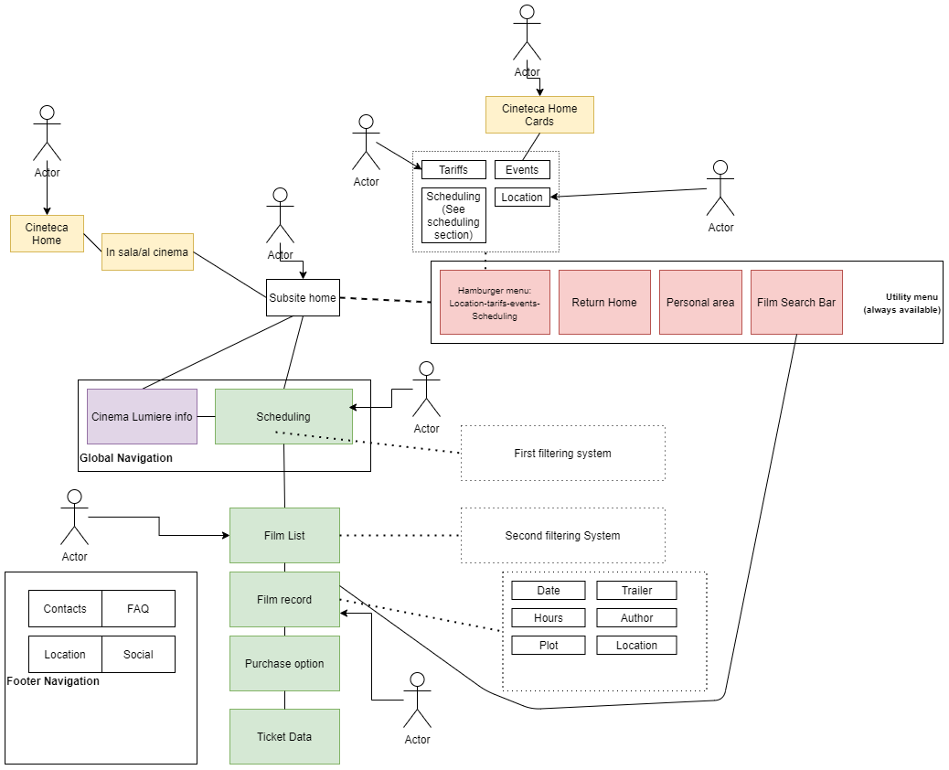

In this second blueprint we highlight some of the different possible navigation patterns that are available in the website. We thought to use an open structure due to navigation patterns found in the target users.

The most linear and classic way of accessing the website is from accessing the Cineteca homepage, through the button “In Sala” (which we suggest to our client to change in “Al Cinema”) the user will access the subsite and then start the navigation to the wanted information or service. As previously mentioned, the global navigation system will make the user able to access scheduling options and start the purchasing process or follow the Cinema Lumiere section. The utility menu provides then access to the other important aspects of the website like prices, locations, contacts and events. A search bar usable only to find single movies will represent the shortcut for expert users to avoid the guided process given by the service.

Our observations showed us that users have also another navigation pattern responding to the formulation *movie/event + name of the cinema* searched in the browser search option. According to this way of accessing the website we provides the possibility of entering the structure from different points. Users could skip the Cineteca website going directly in the subsite home or they could access different sections. Our findings suggests that, besides home, *costs, schedule, location, film list* and *film record* will be the most frequent access point of the website.

As already highlighted the utility menu will give access to main sections of the website allowing users to perform a non linear navigation of the website.

We provide a final mention to the upper-right blueprint section. It is possible to see another link between Cineteca and the subsite. Indeed the mother website provides a series of *cards* in the homepage talking about events and specifically of *Rassegne*. We preserved this connection, clicking on a homepage card will automatically give access to the subsite, specifically in the *Events/Rassegne* section without interrupting users flow of actions.

## 

## Wireframes

In this section we show the website wireframes we designed for the application.

### Cineteca homepage

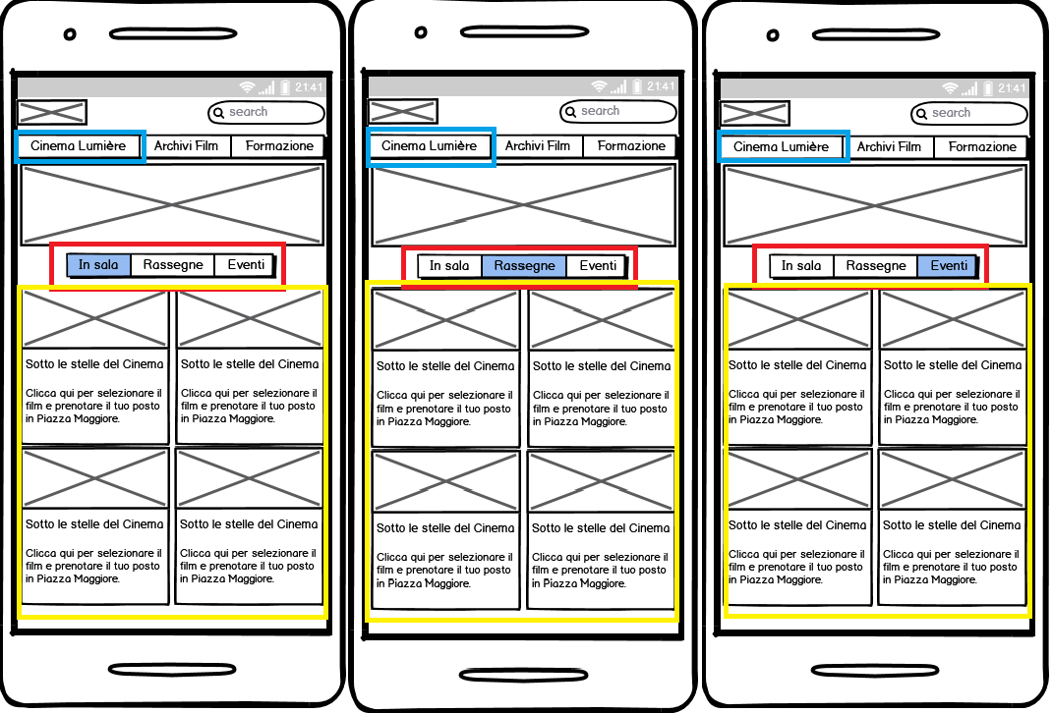

This first set of wireframes shows a lightly redesigned homepage of the Cineteca. We removed the calendar and the contextual navigation to create a design more adequate to a smartphone. We did not modify any other aspects of the website since this would eventually require more discussion with our client, and we limited our intervention only to elements regarding the interconnection between the Cineteca and our design proposal.

Squared in red are filters that are already present in the cineteca website. Clicking on them will change the content of the yellow square. Due to nature of this design, a prototype, we did not change each time the content.

The ways to access the subsite are 2, clicking on one of the box in the yellow square. This possibility will be discussed in following sections.  
The way to access the subsite homepage is through clicking the blue rectangle “Cinema Lumiere”.

### 

### Cinema Lumière homepage

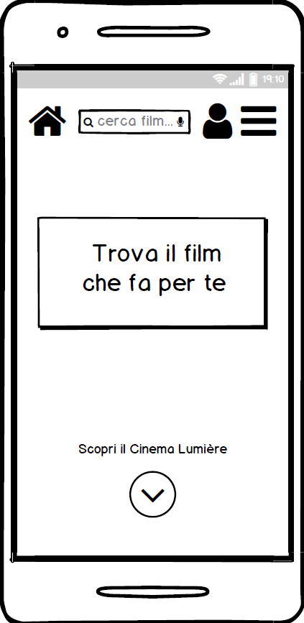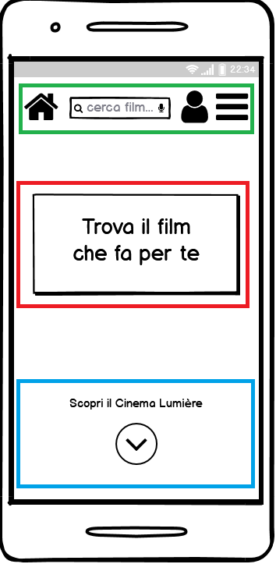

After clicking on Cinema Lumière, users will land on this homepage. The homepage is quite free of content, leaving only a central huge button (squared in red) that will start the schedule process. Simplicity is something extremely valued by our users.

The second possibility is to click the down arrow squared in blue that will give access to information strictly related to Cinema Lumière, while utility navigation tools are in the upper navbar squared in green.

We used common symbols to make easier for users to predict the functions of each button. From right to left, in the upper section of the page there are a *return to homepage button*, a *search bar* (with the text “Cerca film…” suggesting that it only works with cinema titles), a *personal area* and the classic *hamburger menu*.

### 

### Information on Lumière path

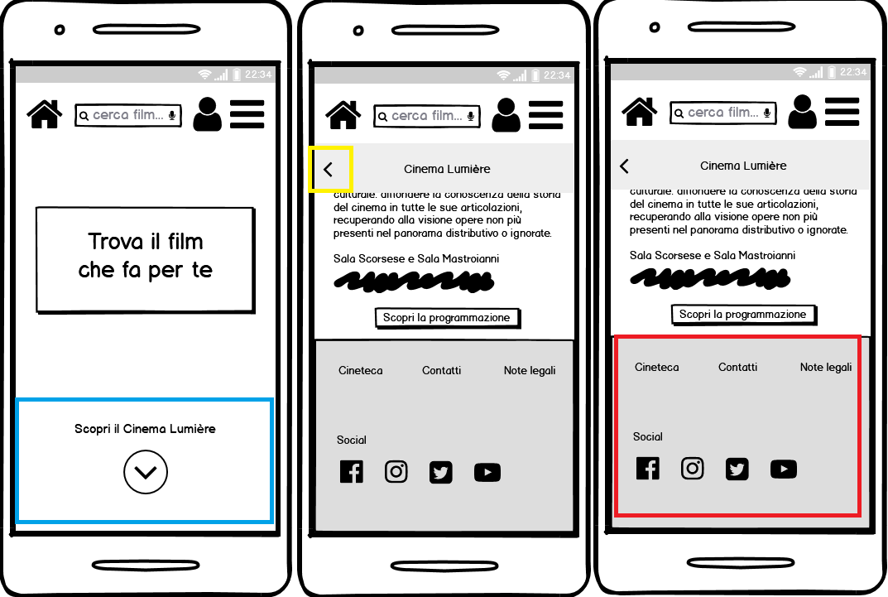

Scrolling down in the homepage or clicking the down button, the uses will reach the central wireframe with information about the cinema and finally a footer. The squared yellow arrow allows the user to go back to the previous page.

In the footer, inside the red rectangle it is possible to see classical elements of footer navigation with the possibility of going back to the mother website, access the contacts section. Social media links are also placed here.

### 

### Schedule and simple filters

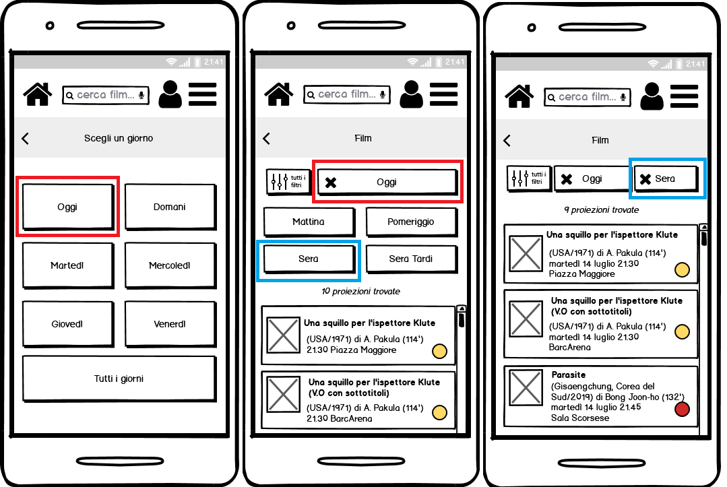

Clicking on the button in the homepage, the user will start the schedule consultation and eventually the purchase path. As a first step the user will have to choose the day of interest. This selection will filter the schedule: the active filter will remain visible and 4 more will be available allowing to restrict even more the possible choices. Also, this filter will remain visible under the navbar. Each filter is reversible.

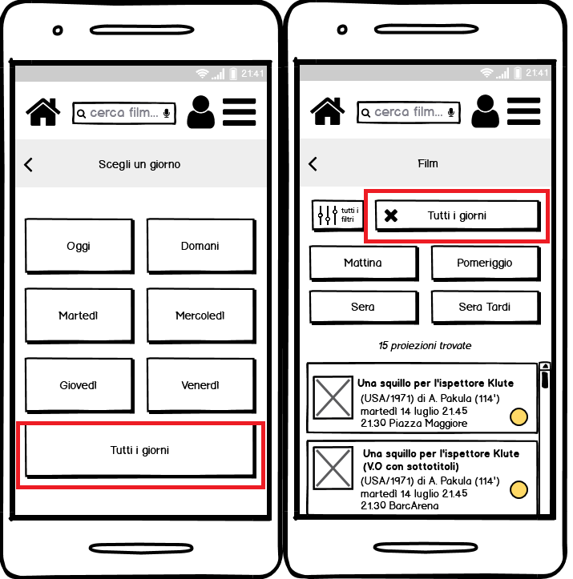

Apart from the first filter (e.g. Tutti i giorni) that is compulsory for the user and puts them in the flow of the activity, pushing them to filter more and be faster in the information research, all the other filters are completely optional: the user can also choose to scroll down the movie showing list to find what they are looking for.

### Schedule and advanced filters

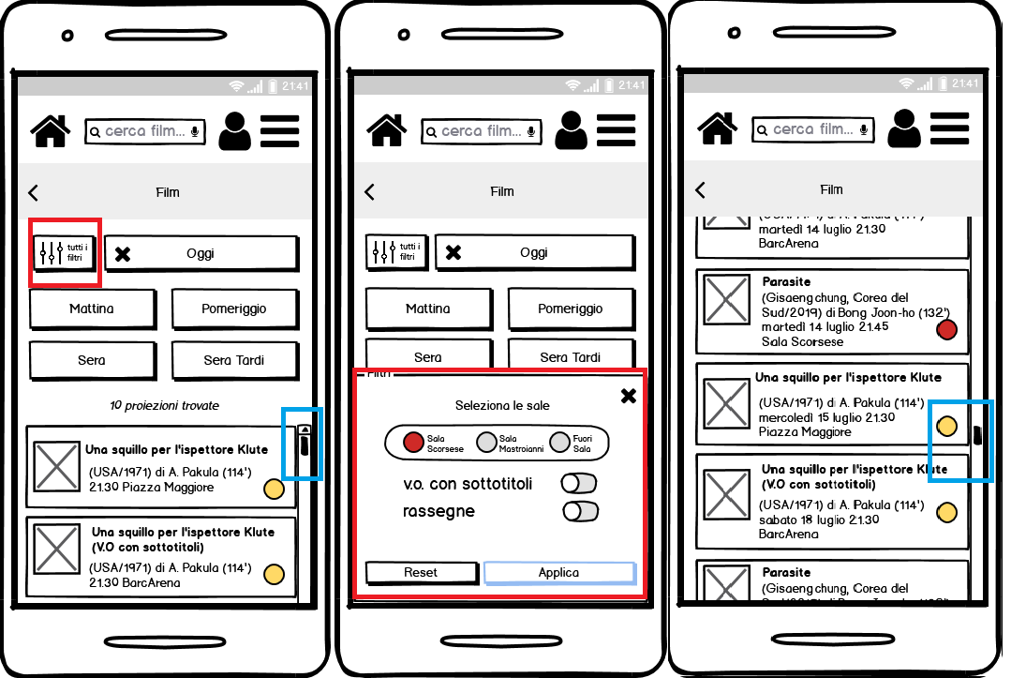

A system of advanced filters is implemented and it’s positioned on the left of the other filters. It will be possible to choose specific theaters, to see movies belonging to “Rassegne” or in their original language with subtitles. A scroll option, highlighted with blue, is present inside the page making possible not to use other filters.

### 

### Movie record

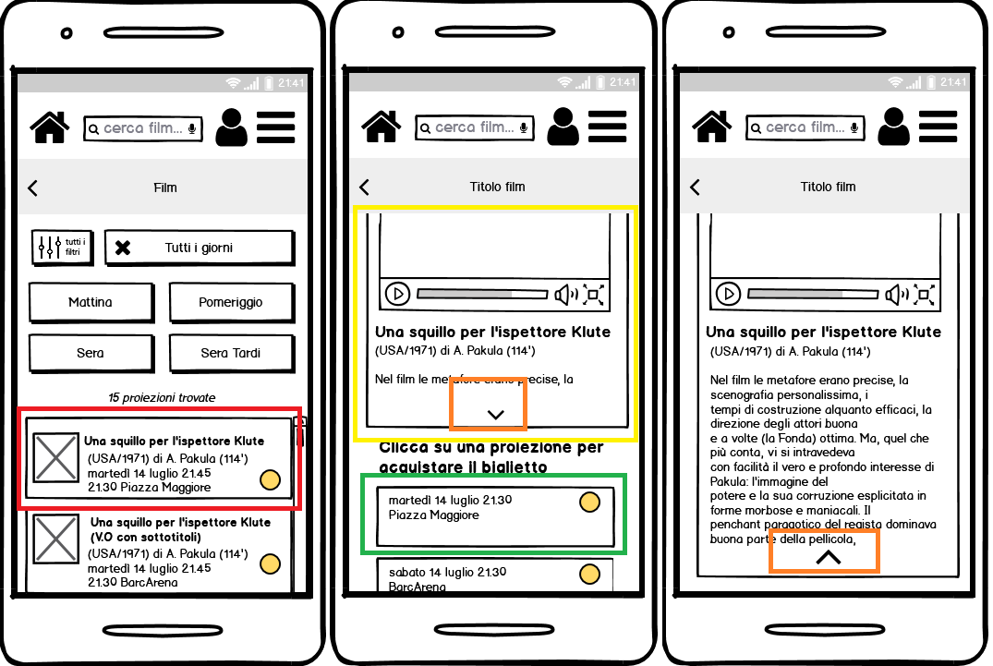

Clicking on the movie showing box (squared in red) will allow users to access the single film page. Here they will find a general overview of the film with its trailer (yellow square) and the list of projections starting from the selected in the previous section. The information box is expansible through the use of the down arrow (in orange): the content inside is a deeper explanation of the film plot and related details.

### 

### Purchase process - Step 1: Log in or registration

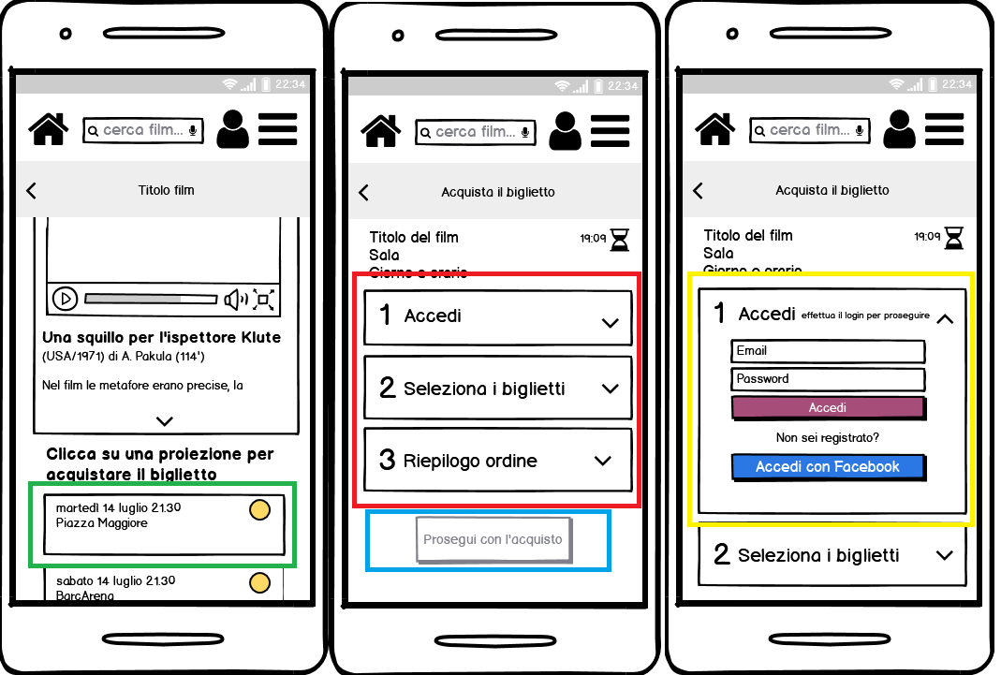

Clicking the single projection will start the proper purchasing process composed of 3 subsequent steps highlighted in the second wireframe: *Log in, Choose ticket, Order recap,* they are squared in red. It is important to say that, as in the marked blue square, users cannot go on without finishing each section. Each one will work as the one in the third wireframe, even if with different content. Like in the actual Cineteca online purchasing service the login and/or registration (even with Facebook) are mandatory actions to be performed by users.

### 

### Purchase process - Step 2: Seats selection

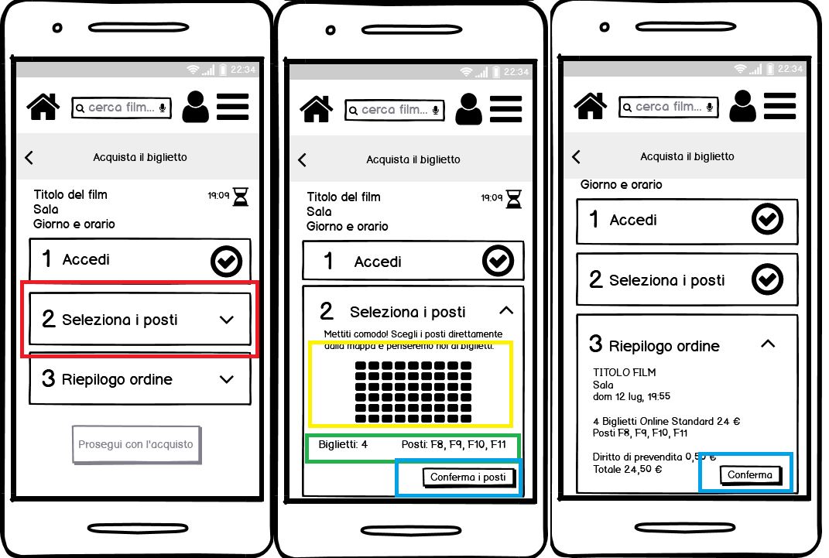

In each dropdown the user will perform a different action. Due to the software limitation it is not possible to see it in a proper way, but inside the yellow square all seats (the little black square) will be not-colored and clickable by the user. An automatic counter, marked with the green figure will keep track of selected seats. Clicking the confirmation button inside the blue square the user will confirm the completion of the activity. The same action will be done by users after reading the correctness of the “Riepilogo ordine” remembering them the amount of seats selected and the total money amount.

### 

### Purchase process - Step 3: Order recap

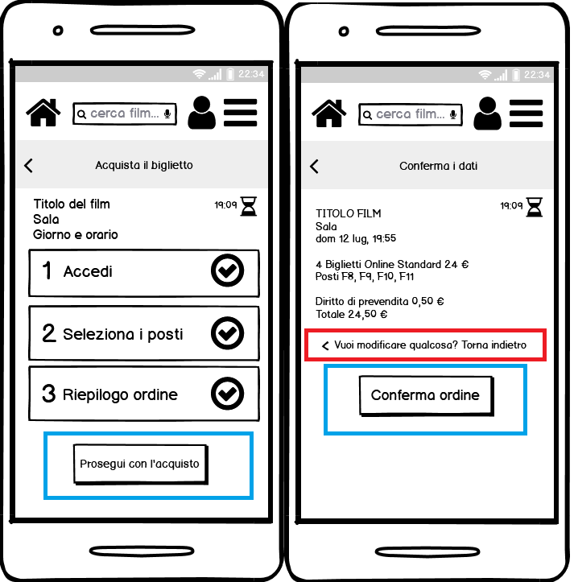

After the end of all 3 steps user will be able to click the button “Prosegui con l’acquisto”, a last recap will be shown. Data displayed here are *film title, theater, date, number of tickets, money amount*. If users find an error, an explicit function is available (marked in red) so that they can come back to the previous page to open dropdown and modify the order. If it is all ok with “Conferma ordine” users will access the banking site to complete the operation. We did not design the bank web page because outside the borders of our proposal.

### 

### Purchase process - Purchase completion

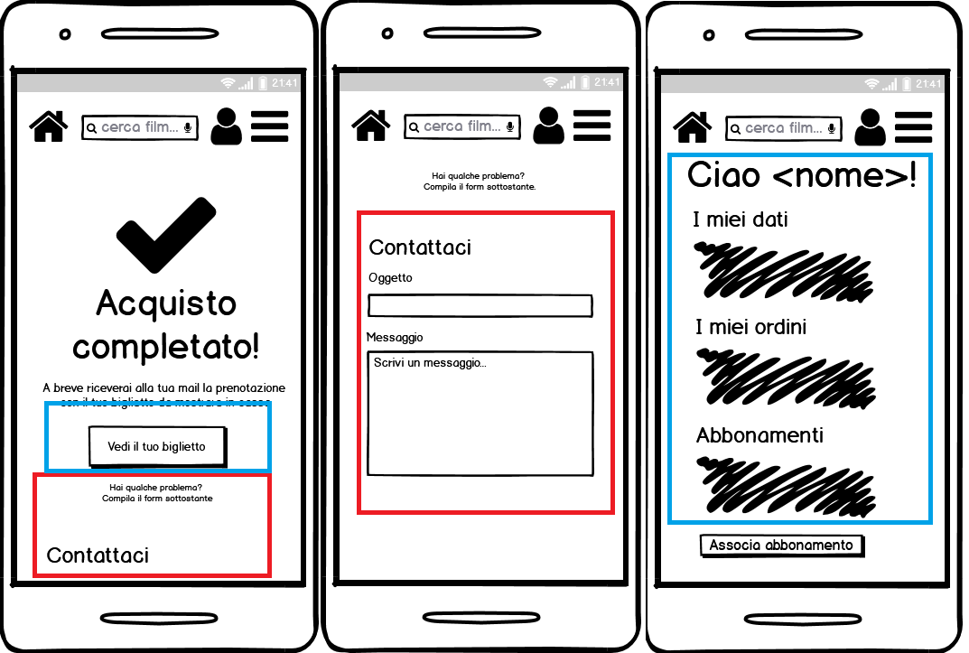

The completion of the operation will open the successful result web page. The central button “Vedi il tuo biglietto” (blue square) will bring users to the third wireframe with personal information and their tickets. In case of problems users could also use the “Contattaci” function placed under the ticket button. Users will have access to the webpage of the second wireframe. A simple structure with 2 text input fields one for message object and the other for the real content.

### 

### Hamburger menu - Programmazione, Dove siamo

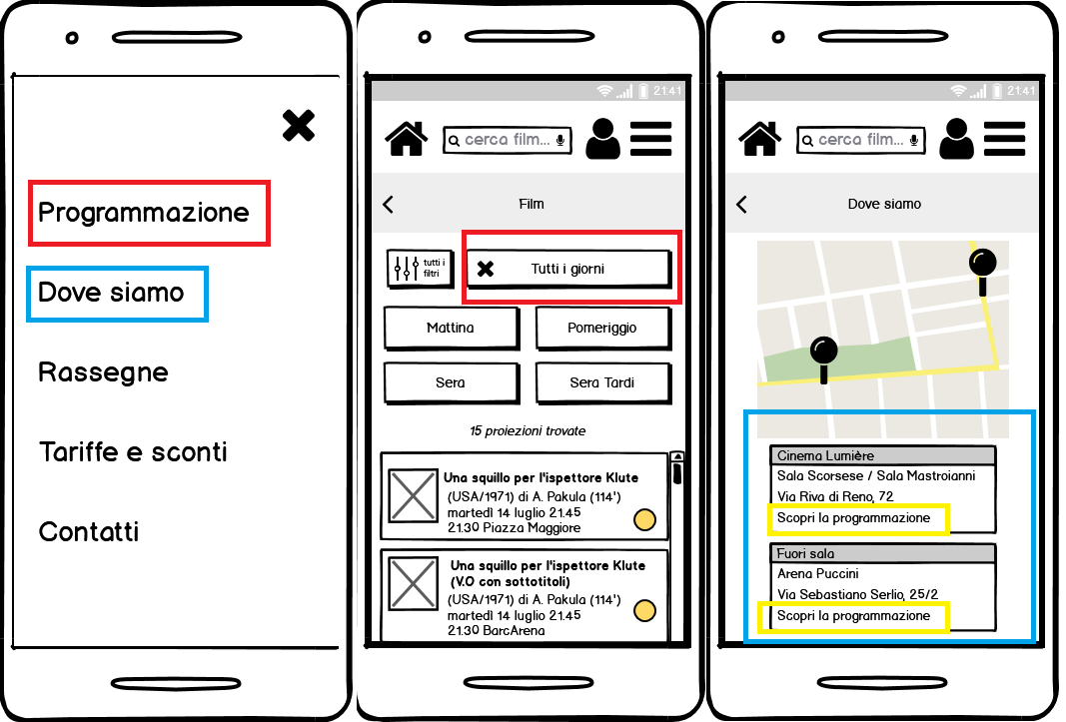

Like we’ve already mentioned before an utility navigation identified in the upper navbar will be always available in the website. Clicking on the hamburger menu will open the screen of the first wireframe. 5 categories are list.

Clicking on Programmazione, the user will land on the schedule with “tutti i giorni” filter applied.

Clicking on Dove siamo, an user will access the map of all Lumière and related theaters/projection areas. Boxes highlighted in blue will have the addresses and names of different locations. Marked in yellow there is the possibility of going back to the schedule.

### 

### Hamburger menu - Rassegne

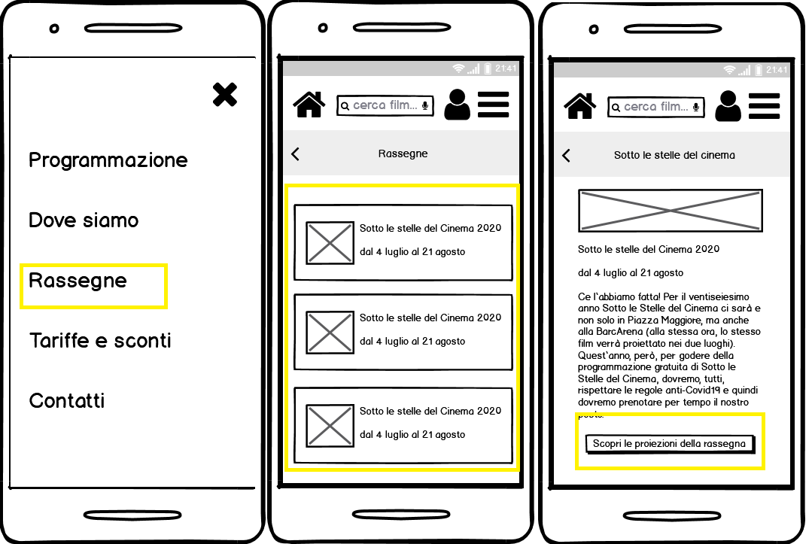

Clicking on it will result on landing on the page with a list of available events. Users will be able to choose a specific one, read the information present in the third wireframe and then, if they want, to use the button highlighted in yellow in the last wireframe to go back to schedule with already the filter “Rassegne” active.

### 

### Hamburger menu - Tariffe e sconti

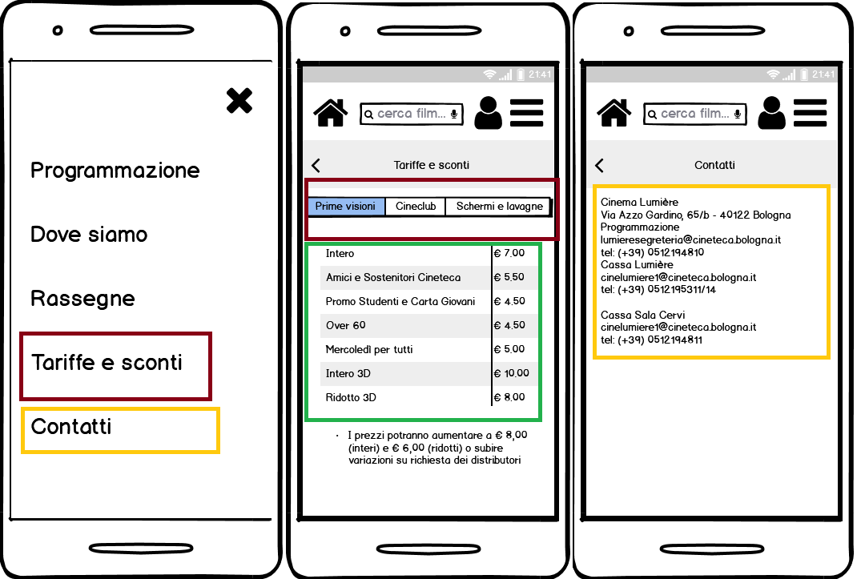

*Tariffe e sconti*: this selection will lead users to the costs section. In the second wireframe, marked in brown rectangle, there are 3 different types of projection, users could select among them to retrieve the desired information. All prices and specification are listed in the central table inside the green square.

*Contatti:* This selection will lead the user to the contacts web page. All relevant information will be listed inside the page with no other possible action.

### 

### Homepage - Search bar

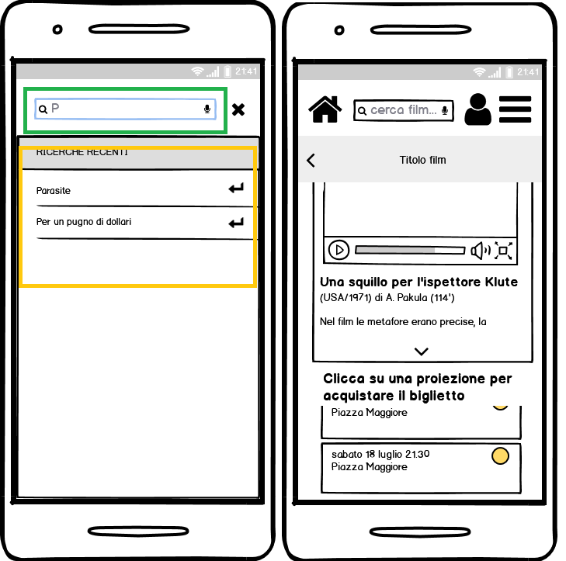

Clicking on the search bar will result in the opening of a complete search screen. The input field, marked in green in the first wireframe, will accept text typed by users. The system will provide advices (marked with orange square) to users remembering previous reducing as much as possible the user memory load. The search bar could be used only to search movies and not other elements.   
Using the search bar users accesses the single film page.